NGOs, NPOs, charities

NGO
A non-governmental organization (NGO) is any non-profit, voluntary citizens' group which is organized on a local, national or international level. Task-oriented and driven by people with a common interest, NGOs perform a variety of service and humanitarian functions, bring citizen concerns to Governments, advocate and monitor policies and encourage political participation through provision of information. Some are organized around specific issues, such as human rights, environment or health. They provide analysis and expertise, serve as early warning mechanisms and help monitor and implement international agreements. Their relationship with offices and agencies of the United Nations system differs depending on their goals, their venue and the mandate of a particular institution.
The number of NGOs worldwide is estimated to be 3.7 million.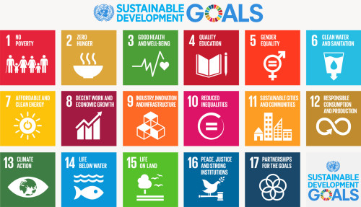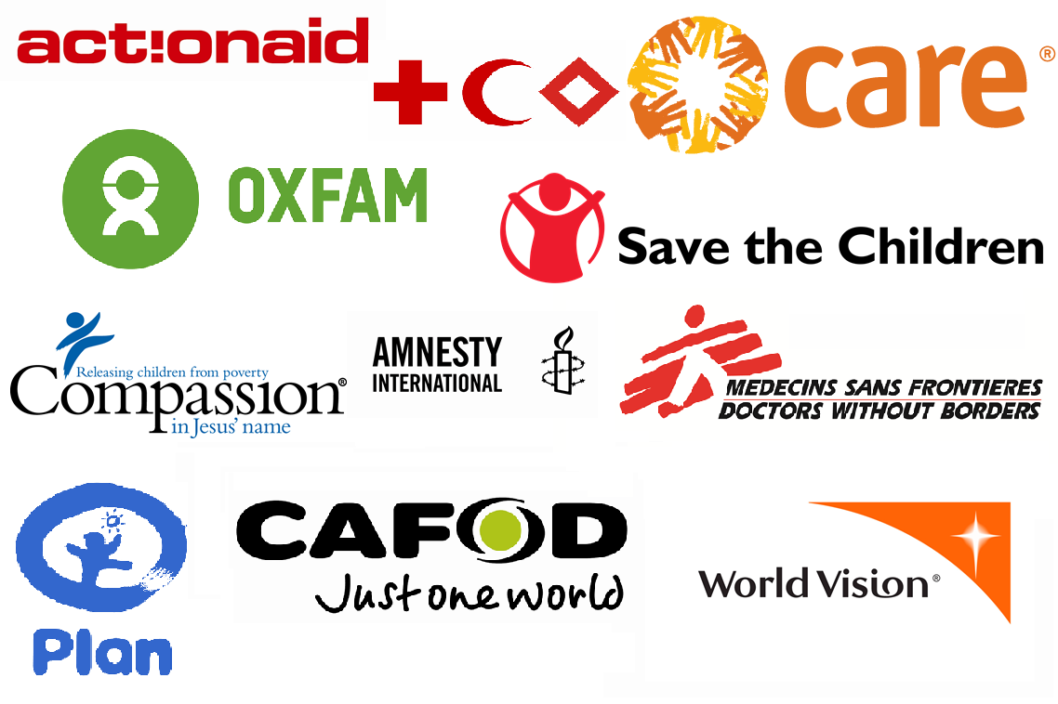

More info:
https://en.wikipedia.org/wiki/Non-governmental_organization
https://www.fic.nih.gov/Global/Pages/NGOs.aspx
https://www.unodc.org/ngo/list.jsp
http://www.sos-childrensvillages.org/
https://www.unicef.org/
https://www.oxfam.org/
The List: The World’s Most Powerful Development NGOs
http://foreignpolicy.com/2008/07/01/the-list-the-worlds-most-powerful-development-ngos/

NPO
Associations, charities, cooperatives, and other voluntary organizations formed to further cultural, educational, religious, professional, or public service objectives. Their start-up funding is provided by their members, trustees, or others who do not expect repayment, and who do not share in the organization's profits or losses which are retained or absorbed. Approved, incorporated, or registered NPOs are usually granted tax exemptions, and contributions to them are often tax deductible. Most non-governmental organizations (NGOs) are NPOs. Also, called not-for-profit organization.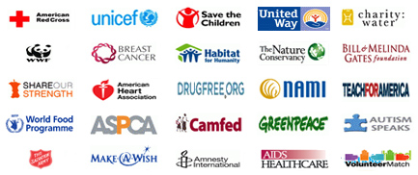
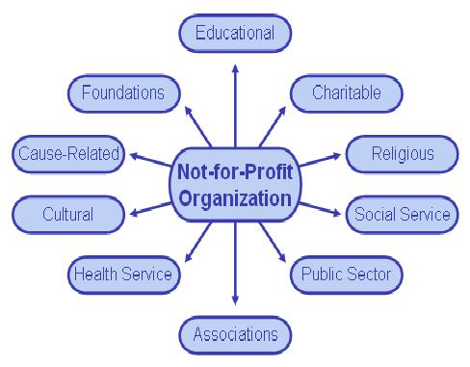

Well known NPOs:
Amnesty International, Oxfam, Rotary International, Kiwanis International, FIDH International Federation for Human Rights, Habitat for Humanity, the Red Cross and Red Crescent organizations, UNESCO, IEEE, INCOSE, World Wide Fund for Nature, Heifer International, Translators Without Borders and SOS Children's Villages.

Charity
An organization set up to provide help and raise money for those in need.
A charitable organization is a type of non-profit organization (NPO). It differs from other types of NPOs in that it centers on philanthropic goals as well as social well-being (e.g. charitable, educational, religious, or other activities serving the public interest or common good).
10 Most Frequently Viewed Charities
https://www.charitynavigator.org/index.cfm?bay=topten.detail&listid=15
Top Rated Charities
https://www.charitywatch.org/top-rated-charities
Percentage of the population who gave to charity in the last four weeks in England in 2015/2016, by age group*
https://www.statista.com/statistics/292936/giving-to-charity-in-england-uk-y-on-y-by-age/

